**Import packages:**

import pandas as pd

import numpy as np

from sklearn import tree

from sklearn import preprocessing

from sklearn import tree

**Import data:**

da=pd.read_excel("Bank_Personal_Loan_Modelling.xlsx",sheet_name=1)

**Describe the data:**

da.dtypes

da.describe()

#checking null values are existing:

da.isnull().sum()

**Deleting unwanted variables:**

del da["ID"]

del da["ZIP Code"]

#round the float variable

da["CCAvg"]=np.round(da["CCAvg"])

**Apply random forest:**

fea1=['Age', 'Experience', 'Income', 'Family', 'CCAvg', 'Education',

'Mortgage', 'Securities Account', 'CD Account',

'Online', 'CreditCard']

from sklearn.ensemble import RandomForestClassifier

rfc= RandomForestClassifier(n_estimators=1000,max_features=2,oob_score=True)

rfc.fit(X=da[fea1], y=da["Personal Loan"])

**Accuracy of model:**

print(rfc.oob_score_)

0.9868

for fea,imp in zip(fea1,rfc.feature_importances_):

print(fea,imp);

Age 0.05064252071996918

Experience 0.05039205797457909

Income 0.36187917978624234

Family 0.09972283861269829

CCAvg 0.14112459884320652

Education 0.1681377379459456

Mortgage 0.047570892011467074

Securities Account 0.006350760207447376

CD Account 0.05376601266419026

Online 0.009591957782271267

CreditCard 0.01082144345198308

#extract importent variables:

finfea=['Family',"Education","CCAvg","Income"]

finmod=tree.DecisionTreeClassifier(max_depth=8,max_leaf_nodes=10)

finmod.fit(X=da[finfea], y=da["Personal Loan"])

finmod.score(X=da[finfea], y=da["Personal Loan"])

Out[4]: 0.9922

Confusion matrix for trainset

trainpre=finmod.predict(X=da[finfea])

from sklearn.metrics import confusion_matrix

traincm=confusion_matrix(trainpre,da["Personal Loan"])

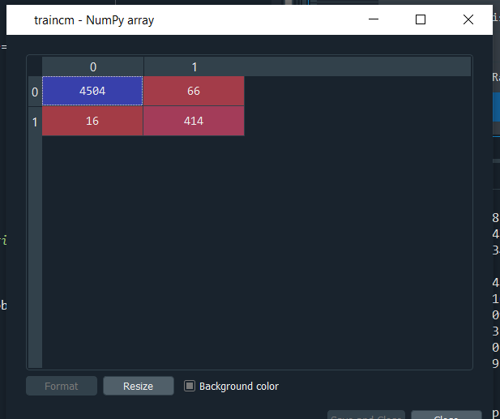

**Predict:**

testda=da.sample(frac=0.25)

testpre=finmod.predict(X=testda[finfea])

testcm=confusion_matrix(testpre,testda["Personal Loan"])

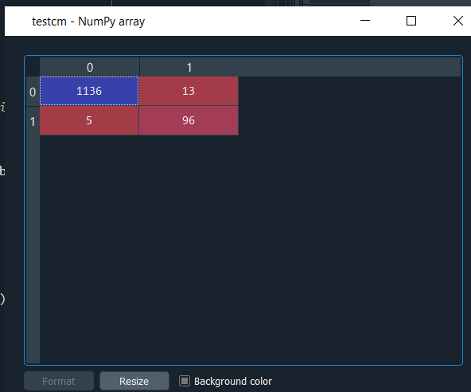

predata=pd.DataFrame({"Income":da["Income"],"Personal Loan":testpre})

**Pictorial format:**

with open("loantree.dot","w") as f:

f=tree.export_graphviz(finmod,feature_names=finfea,out_file=f);

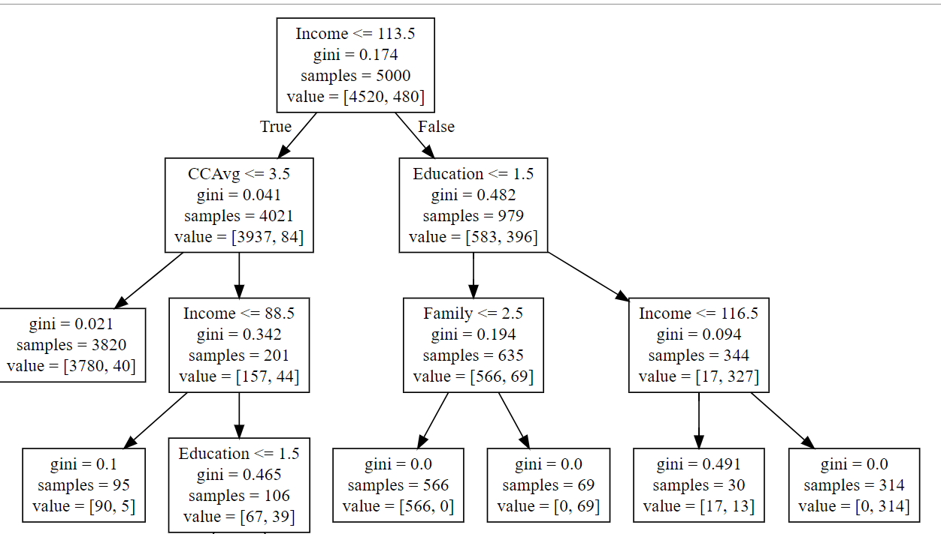

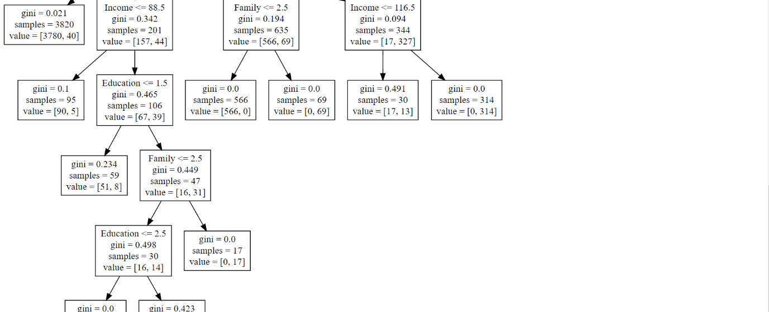

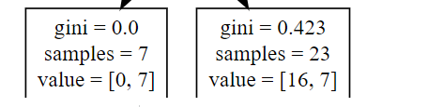

**Rules:**

If peoples who have Income <= 113.5=False&Education <= 1.5=False & Income <= 116.5=False .they would get personal loan 1.

peoples who have Income <= 113.5=False& Education <= 1.5=True& Family <= 2.5=False .they would get personal loan 1.

peoples who have Income <= 113.5=False& Education <= 1.5=True& Family <= 2.5=True .they would get personal loan 0.